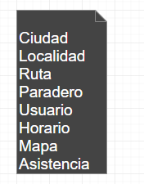

|  |  |  |  |  |  |  |  |
| --- | --- | --- | --- | --- | --- | --- | --- |
|  | Ciudad | Localidad | Ruta | Paradero | Usuario | Horario | Asistencia |
| Ciudad | X | 1:M | X | X | X | X | X |
| Localidad | 1:1 | X | X | 1:M | X | 1:M | X |
| Ruta | X | X | X | 1:M | 1:M | 1:1 | X |
| Paradero | X | X | 1:M | X | X | 1:M | X |
| Usuario | X | 1:M | 1:M | 1:M | X | 1:M | 1:M |
| Horario | X | 1:M | 1:M | X | X | X | X |
| Asistencia | X | X | X | X | M:M | X | X |